CLIENT-SERVER COMMUNICATION FLOW

1. Scenario
This project demonstrates a simple network topology using one router, two switches, one laptop, and one server. The network is designed to connect an end-user device to a server through network infrastructure devices.
The router (R1) connects two separate network segments. Switch S1 provides connectivity for Laptop0, while Switch S2 connects the server (Carver0). The router forwards traffic between these two segments, allowing the laptop and server to communicate when the appropriate IP addressing and routing configurations are applied.
This topology can be used as a basic networking lab to practice device configuration, IP addressing, interface setup, and end-to-end connectivity testing.

2. Scope
The scope of this project includes the following:
- Network devices: One router (R1), two switches (S1 and S2), one laptop (Client), and one server (Server).
- Physical connections: Ethernet connections between the laptop and S1, S1 and R1, R1 and S2, and S2 and the server.
- IP addressing: Assign IP addresses and subnet masks to the end devices and router interfaces.
- Router configuration: Configure router interfaces to enable communication between the two network segments.
- Switch configuration: Establish Layer 2 connectivity between the connected devices.
- Connectivity testing: Use commands such as ping to verify communication between the laptop, router, and server.
The project focuses on basic LAN connectivity and inter-network routing.

3. Objective
The main objective is to design, configure, and test a small network using Cisco Packet Tracer.
The specific objectives are to:
- Understand how routers and switches connect devices in a network.
- Configure router interfaces and end-device IP addresses correctly.
- Understand how a router enables communication between different IP subnets.
- Verify network connectivity using ping and interface status commands.
- Troubleshoot common networking problems, including incorrect IP addresses, subnet masks, default gateways, and disabled interfaces.
- Document the network topology and configuration for future reference.

4. Scheme
Network Topology
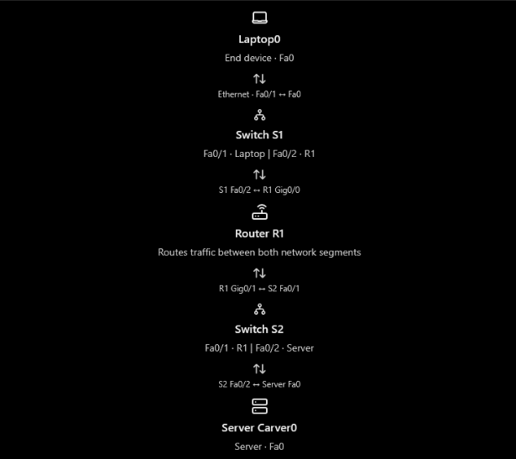
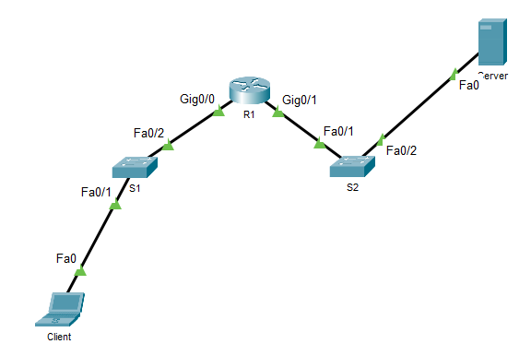

IP address scheme
Device | Interface | IP address | Subnet mask | Default Gateway
R1 | Gig 0/0  Gig 0/1 | 10.1.0.1  10.0.0.1 | 255.255.255.0  255.255.255.0
Server |  | 10.0.0.2 | 255.255.255.0 | 10.0.0.1
Client |  | 10.1.0.2 | 255.255.255.0 | 10.1.0.1

5. Summary
This project illustrates the fundamentals of connecting end devices through switches and a router. The two switches provide local connectivity, while R1 connects the two IP networks and routes traffic between them.

